**2.9 Three Color ESL image format**

**Revision History**

|  |  |  |  |
| --- | --- | --- | --- |
| **Version** | **Date** | **Change Description** | **Author** |
| V1.0 | 2018/7/13 | Initial version | Ning |
|  |  |  |  |
|  |  |  |  |
|  |  |  |  |
|  |  |  |  |
|  |  |  |  |
|  |  |  |  |
|  |  |  |  |

**C O N F I D E N T I A L**

. **Catalogue**

1. Purpose 3

2. ESL Image Format 3

3. Appendix 4

# Purpose

This article describes the ESL image encoding format, which is used to guide third parties to develop images that are generated by the tag generated by their own programs.

# ESL Image Format

129, 1

130,2

3

4

5

6

…

128

The display of the 2.9-inch electronic label is displayed from right to left and from top to bottom.

The resolution of the 2.9-inch electronic tag is 296*128, which is equivalent to 37888 pixels. Each pixel adopts three-color display, corresponding to binary 00(black) , 01(white) and 10(red),. If byte encoding is used, it is equivalent to 1 byte and can represent 4 pixels. That is, it can be represented by 37888/4=9472 bytes.

Example 1: Need to do the following display



1) The top rightmost column (upper right corner) shows 3 black dots;

2) The bottom right column shows 1 red dot (lower right corner);

The corresponding code is as follows:

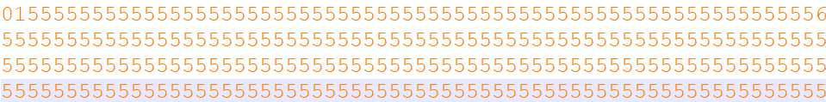

For 2.9 inch three color ESL, one column need 32 bytes (128 pixels).

The First Column:

* The first byte was 0x01: Corresponding binary digit: 0000 0001, that is, the first 3 pixels are 00,00,00, which is black.
* The last byte was 0x56: Corresponding binary digit:

# Appendix

1. We also attach a file "example.bmp" file in the attachment directory, and we also provide the mqtt message that include image content (example.bmp.json).

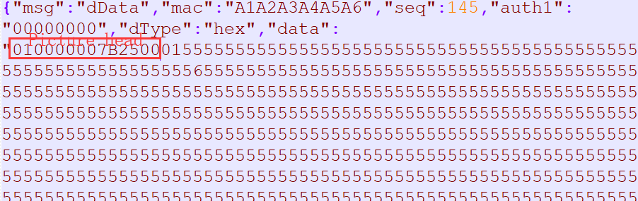

2. We also attach a file “example.bmpz.json” in the same directory. This file was compression encoding. You can see that the file size is very small. We recommend using compressing encoding json message for 2.9inch three color ESL when sending picture to ESL.